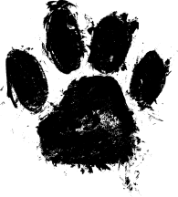 Pet PAWrade registration form
Enter your favorite animal friend and join in on the fun at the annual Pet PAWrade at the Donald W. Reynolds Community Center & Library on Saturday, DOGust 25th, 2018 at 11:00am.
Each participant will receive a free prize! There will be pet related booths with local vendors and volunteer organizations.

Registration Agreement
Owner Name: __________________________________________________________________
Pet Name: ________________________________ Type of Animal: _______________________
Address: ______________________________________________________________________
City: _____________________________ State: ____________ Zip: __________________
Phone: ____________________________ Email: ____________________________________

I waive all claims against Donald W. Reynolds Community Center and Library, the City of Durant, and officials for any injury or illness which may directly or indirectly result from my participation in the pet pawrade and activities of the day.
Signature: ______________________________________________ Date: ________________

For more information about the pet pawrade, please contact Angie Mullen at the library, 1515 W. Main St. 580-924-3486 press 1.

Pet supplies donations are welcomed that will benefit local area pet rescues!

